Machine Learning
Chapter 1
Introduction to Machine Learning
- What is Machine Learning?
- Motivation: Why Machine Learning?
- Applications of Machine Learning
- Designing a Learning System
- Issues in Machine Learning

INTRODUCTION
Ever since computers were invented, we have wondered whether they might be made to learn. If we could understand how to program them to learn-to improve automatically with experience-the impact would be dramatic.
- Imagine computers learning from medical records which treatments are most effective for new diseases
- Houses learning from experience to optimize energy costs based on the particular usage patterns of their occupants.
- Personal software assistants learning the evolving interests of their users in order to highlight especially relevant stories from the online morning newspaper

A successful understanding of how to make computers learn would open up many new uses of computers and new levels of competence and customization

Some successful applications of machine learning
- Learning to recognize spoken words
- Learning to drive an autonomous vehicle
- Learning to classify new astronomical structures
- Learning to play world-class backgammon

Why is Machine Learning Important?

- Some tasks cannot be defined well, except by examples (e.g., recognizing people).
- Relationships and correlations can be hidden within large amounts of data. Machine Learning/Data Mining may be able to find these relationships.
- Human designers often produce machines that do not work as well as desired in the environments in which they are used.
- The amount of knowledge available about certain tasks might be too large for explicit encoding by humans (e.g., medical diagnostic).
- Environments change over time.
- New knowledge about tasks is constantly being discovered by humans. It may be difficult to continuously re-design systems “by hand”.

Supervised Machine Learning
Supervised learning is the types of machine learning in which machines are trained using well "labelled" training data, and on basis of that data, machines predict the output. The labelled data means some input data is already tagged with the correct output.
In supervised learning, the training data provided to the machines work as the supervisor that teaches the machines to predict the output correctly. It applies the same concept as a student learns in the supervision of the teacher.
Supervised learning is a process of providing input data as well as correct output data to the machine learning model. The aim of a supervised learning algorithm is to find a mapping function to map the input variable(x) with the output variable(y).
In the real-world, supervised learning can be used for Risk Assessment, Image classification, Fraud Detection, spam filtering, etc.
Difference between JDK, JRE, and JVM

How Supervised Learning Works?
In supervised learning, models are trained using labelled dataset, where the model learns about each type of data. Once the training process is completed, the model is tested on the basis of test data (a subset of the training set), and then it predicts the output.
The working of Supervised learning can be easily understood by the below example and diagram:
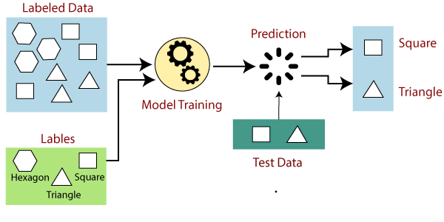
Suppose we have a dataset of different types of shapes which includes square, rectangle, triangle, and Polygon. Now the first step is that we need to train the model for each shape.
- If the given shape has four sides, and all the sides are equal, then it will be labelled as a Square.
- If the given shape has three sides, then it will be labelled as a triangle.
- If the given shape has six equal sides then it will be labelled as hexagon.
Now, after training, we test our model using the test set, and the task of the model is to identify the shape.
The machine is already trained on all types of shapes, and when it finds a new shape, it classifies the shape on the bases of a number of sides, and predicts the output.

Steps Involved in Supervised Learning:
- First Determine the type of training dataset
- Collect/Gather the labelled training data.
- Split the training dataset into training dataset, test dataset, and validation dataset.
- Determine the input features of the training dataset, which should have enough knowledge so that the model can accurately predict the output.
- Determine the suitable algorithm for the model, such as support vector machine, decision tree, etc.
- Execute the algorithm on the training dataset. Sometimes we need validation sets as the control parameters, which are the subset of training datasets.
- Evaluate the accuracy of the model by providing the test set. If the model predicts the correct output, which means our model is accurate.

Types of supervised Machine learning Algorithms:
Supervised learning can be further divided into two types of problems:
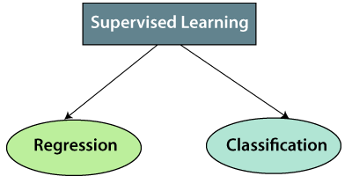
1. Regression
Regression algorithms are used if there is a relationship between the input variable and the output variable. It is used for the prediction of continuous variables, such as Weather forecasting, Market Trends, etc. Below are some popular Regression algorithms which come under supervised learning:
- Linear Regression
- Regression Trees
- Non-Linear Regression
- Bayesian Linear Regression
- Polynomial Regression
2. Classification
Classification algorithms are used when the output variable is categorical, which means there are two classes such as Yes-No, Male-Female, True-false, etc.
Spam Filtering,
- Random Forest
- Decision Trees
- Logistic Regression
- Support vector Machines

Note: We will discuss these algorithms in detail in later chapters.

Advantages of Supervised learning:
- With the help of supervised learning, the model can predict the output on the basis of prior experiences.
- In supervised learning, we can have an exact idea about the classes of objects.
- Supervised learning model helps us to solve various real-world problems such as fraud detection, spam filtering, etc.

Disadvantages of supervised learning:
- Supervised learning models are not suitable for handling the complex tasks.
- Supervised learning cannot predict the correct output if the test data is different from the training dataset.
- Training required lots of computation times.
- In supervised learning, we need enough knowledge about the classes of object.

Unsupervised Machine Learning
In the previous topic, we learned supervised machine learning in which models are trained using labeled data under the supervision of training data. But there may be many cases in which we do not have labeled data and need to find the hidden patterns from the given dataset. So, to solve such types of cases in machine learning, we need unsupervised learning techniques.

What is Unsupervised Learning?
As the name suggests, unsupervised learning is a machine learning technique in which models are not supervised using training dataset. Instead, models itself find the hidden patterns and insights from the given data. It can be compared to learning which takes place in the human brain while learning new things. It can be defined as:
Unsupervised learning is a type of machine learning in which models are trained using unlabeled dataset and are allowed to act on that data without any supervision.
Unsupervised learning cannot be directly applied to a regression or classification problem because unlike supervised learning, we have the input data but no corresponding output data. The goal of unsupervised learning is to find the underlying structure of dataset, group that data according to similarities, and represent that dataset in a compressed format.
Example: Suppose the unsupervised learning algorithm is given an input dataset containing images of different types of cats and dogs. The algorithm is never trained upon the given dataset, which means it does not have any idea about the features of the dataset. The task of the unsupervised learning algorithm is to identify the image features on their own. Unsupervised learning algorithm will perform this task by clustering the image dataset into the groups according to similarities between images.
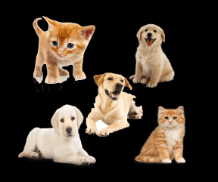

Why use Unsupervised Learning?
Below are some main reasons which describe the importance of Unsupervised Learning:
- Unsupervised learning is helpful for finding useful insights from the data.
- Unsupervised learning is much similar as a human learns to think by their own experiences, which makes it closer to the real AI.
- Unsupervised learning works on unlabeled and uncategorized data which make unsupervised learning more important.
- In real-world, we do not always have input data with the corresponding output so to solve such cases, we need unsupervised learning.

Working of Unsupervised Learning
Working of unsupervised learning can be understood by the below diagram:
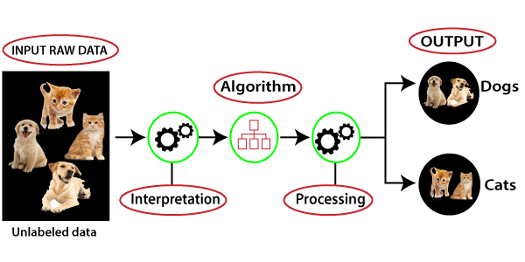
Here, we have taken an unlabeled input data, which means it is not categorized and corresponding outputs are also not given. Now, this unlabeled input data is fed to the machine learning model in order to train it. Firstly, it will interpret the raw data to find the hidden patterns from the data and then will apply suitable algorithms such as k-means clustering, Decision tree, etc.
Once it applies the suitable algorithm, the algorithm divides the data objects into groups according to the similarities and difference between the objects.

Types of Unsupervised Learning Algorithm:
The unsupervised learning algorithm can be further categorized into two types of problems:
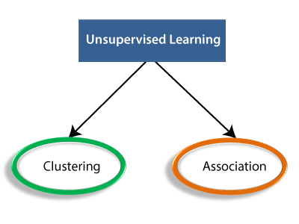
- Clustering: Clustering is a method of grouping the objects into clusters such that objects with most similarities remains into a group and has less or no similarities with the objects of another group. Cluster analysis finds the commonalities between the data objects and categorizes them as per the presence and absence of those commonalities.
- Association: An association rule is an unsupervised learning method which is used for finding the relationships between variables in the large database. It determines the set of items that occurs together in the dataset. Association rule makes marketing strategy more effective. Such as people who buy X item (suppose a bread) are also tend to purchase Y (Butter/Jam) item. A typical example of Association rule is Market Basket Analysis.

Note: We will learn these algorithms in later chapters.

Unsupervised Learning algorithms:
Below is the list of some popular unsupervised learning algorithms:
- K-means clustering
- KNN (k-nearest neighbors)
- Hierarchal clustering
- Anomaly detection
- Neural Networks
- Principle Component Analysis
- Independent Component Analysis
- Apriori algorithm
- Singular value decomposition

Advantages of Unsupervised Learning
- Unsupervised learning is used for more complex tasks as compared to supervised learning because, in unsupervised learning, we don't have labeled input data.
- Unsupervised learning is preferable as it is easy to get unlabeled data in comparison to labeled data.

Disadvantages of Unsupervised Learning
- Unsupervised learning is intrinsically more difficult than supervised learning as it does not have corresponding output.
- The result of the unsupervised learning algorithm might be less accurate as input data is not labeled, and algorithms do not know the exact output in advance.
The main differences between Supervised and Unsupervised learning are given below:
Supervised Learning | Unsupervised Learning
Supervised learning algorithms are trained using labeled data. | Unsupervised learning algorithms are trained using unlabeled data.
Supervised learning model takes direct feedback to check if it is predicting correct output or not. | Unsupervised learning model does not take any feedback.
Supervised learning model predicts the output. | Unsupervised learning model finds the hidden patterns in data.
In supervised learning, input data is provided to the model along with the output. | In unsupervised learning, only input data is provided to the model.
The goal of supervised learning is to train the model so that it can predict the output when it is given new data. | The goal of unsupervised learning is to find the hidden patterns and useful insights from the unknown dataset.
Supervised learning needs supervision to train the model. | Unsupervised learning does not need any supervision to train the model.
Supervised learning can be categorized in Classification and Regression problems. | Unsupervised Learning can be classified in Clustering and Associations problems.
Supervised learning can be used for those cases where we know the input as well as corresponding outputs. | Unsupervised learning can be used for those cases where we have only input data and no corresponding output data.
Supervised learning model produces an accurate result. | Unsupervised learning model may give less accurate result as compared to supervised learning.
Supervised learning is not close to true Artificial intelligence as in this, we first train the model for each data, and then only it can predict the correct output. | Unsupervised learning is more close to the true Artificial Intelligence as it learns similarly as a child learns daily routine things by his experiences.
It includes various algorithms such as Linear Regression, Logistic Regression, Support Vector Machine, Multi-class Classification, Decision tree, Bayesian Logic, etc. | It includes various algorithms such as Clustering, KNN, and Apriori algorithm.

Note: The supervised and unsupervised learning both are the machine learning methods, and selection of any of these learning depends on the factors related to the structure and volume of your dataset and the use cases of the problem.

WELL-POSED LEARNING PROBLEMS

Definition: A computer program is said to learn from experience E with respect to some class of tasks T and performance measure P, if its performance at tasks in T, as measured by P, improves with experience E.

To have a well-defined learning problem, three features needs to be identified:
  - The class of tasks
  - The measure of performance to be improved
  - The source of experience

Examples
- Checkers game: A computer program that learns to play checkers might improve its performance as measured by its ability to win at the class of tasks involving playing checkers games, through experience obtained by playing games against itself.
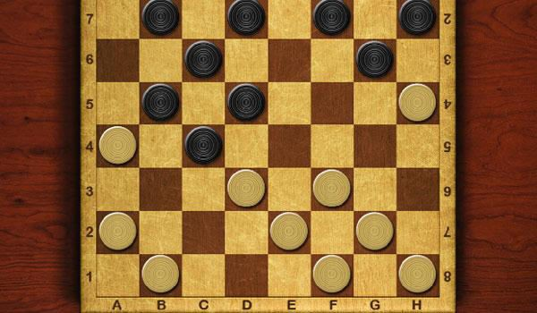
Fig: Checker game board

A checkers learning problem:
  - Task T: playing checkers
  - Performance measure P: percent of games won against opponents
  - Training experience E: playing practice games against itself

A handwriting recognition learning problem:
  - Task T: recognizing and classifying handwritten words within images
  - Performance measure P: percent of words correctly classified
  - Training experience E: a database of handwritten words with given classifications

A robot driving learning problem:
  - Task T: driving on public four-lane highways using vision sensors
  - Performance measure P: average distance travelled before an error (as judged by human overseer)
  - Training experience E: a sequence of images and steering commands recorded while observing a human driver

DESIGNING A LEARNING SYSTEM

The basic design issues and approaches to machine learning are illustrated by designing a program to learn to play checkers, with the goal of entering it in the world checkers tournament
- Choosing the Training Experience
- Choosing the Target Function
- Choosing a Representation for the Target Function
- Choosing a Function Approximation Algorithm
  - Estimating training values
  - Adjusting the weights
- The Final Design

Choosing the Training Experience

  - The first design choice is to choose the type of training experience from which the system will learn.
  - The type of training experience available can have a significant impact on success or failure of the learner.

There are three attributes which impact on success or failure of the learner

- Whether the training experience provides direct or indirect feedback regarding the choices made by the performance system.

For example, in checkers game:
In learning to play checkers, the system might learn from direct training examples
Consisting of individual checkers board states and the correct move for each.

Indirect training examples consisting of the move sequences and final outcomes of various games played. The information about the correctness of specific moves early in the game must be inferred indirectly from the fact that the game was eventually won or lost.

Here the learner faces an additional problem of credit assignment, or determining the degree to which each move in the sequence deserves credit or blame for the final outcome. Credit assignment can be a particularly difficult problem because the game can be lost even when early moves are optimal, if these are followed later by poor moves.
Hence, learning from direct training feedback is typically easier than learning from indirect feedback.
- The degree to which the learner controls the sequence of training examples

For example, in checkers game:
The learner might depends on the teacher to select informative board states and to provide the correct move for each.

Alternatively, the learner might itself propose board states that it finds particularly confusing and ask the teacher for the correct move.

The learner may have complete control over both the board states and (indirect) training classifications, as it does when it learns by playing against itself with no teacher present.

- How well it represents the distribution of examples over which the final system performance P must be measured

For example, in checkers game:
In checkers learning scenario, the performance metric P is the percent of games the system wins in the world tournament.

If its training experience E consists only of games played against itself, there is a danger that this training experience might not be fully representative of the distribution of situations over which it will later be tested.
It is necessary to learn from a distribution of examples that is different from those on which the final system will be evaluated.

Choosing the Target Function

The next design choice is to determine exactly what type of knowledge will be learned and how this will be used by the performance program.

Let’s consider a checkers-playing program that can generate the legal moves from any board state.
The program needs only to learn how to choose the best move from among these legal moves. We must learn to choose among the legal moves, the most obvious choice for the type of information to be learned is a program, or function, that chooses the best move for any given board state.

  - Let ChooseMove be the target function and the notation is

ChooseMove : B→ M
which indicate that this function accepts as input any board from the set of legal board states B and produces as output some move from the set of legal moves M.
ChooseMove is a choice for the target function in checkers example, but this function will turn out to be very difficult to learn given the kind of indirect training experience available to our system

  - An alternative target function is an evaluation function that assigns a numerical score
to any given board state
Let the target function V and the notation

V : B → R

which denote that V maps any legal board state from the set B to some real value. Intend for this target function V to assign higher scores to better board states. If the system can successfully learn such a target function V, then it can easily use it to select the best move from any current board position.

Let us define the target value V(b) for an arbitrary board state b in B, as follows:
- If b is a final board state that is won, then V(b) = 100
- If b is a final board state that is lost, then V(b) = -100
- If b is a final board state that is drawn, then V(b) = 0
- If b is a not a final state in the game, then V(b) = V(b' ),

Where b' is the best final board state that can be achieved starting from b and playing optimally until the end of the game

Choosing a Representation for the Target Function

Let’s choose a simple representation - for any given board state, the function c will be calculated as a linear combination of the following board features:

- x_{l}: the number of black pieces on the board
- x₂: the number of red pieces on the board
- x₃: the number of black kings on the board
- x₄: the number of red kings on the board
- x₅: the number of black pieces threatened by red (i.e., which can be captured on red's next turn)
- x₆: the number of red pieces threatened by black

Thus, learning program will represent as a linear function of the form

Where,
- w₀ through w₆ are numerical coefficients, or weights, to be chosen by the learning algorithm.
- Learned values for the weights w1 through w6 will determine the relative importance of the various board features in determining the value of the board
- The weight w₀ will provide an additive constant to the board value

Choosing a Function Approximation Algorithm

In order to learn the target function f we require a set of training examples, each describing a specific board state b and the training value V_{train}(b) for b.

Each training example is an ordered pair of the form (b, V_{train}(b)).

For instance, the following training example describes a board state b in which black has won the game (note x₂ = 0 indicates that red has no remaining pieces) and for which the target function value V_{train}(b) is therefore +100.

((x₁=3, x₂=0, x₃=1, x₄=0, x₅=0, x₆=0), +100)

Function Approximation Procedure

    - Derive training examples from the indirect training experience available to the learner
    - Adjusts the weights w_{i} to best fit these training examples

- Estimating training values

A simple approach for estimating training values for intermediate board states is to
assign the training value of V_{train}(b) for any intermediate board state b to be V̂ (Successor(b))

Where ,
  - V̂ is the learner's current approximation to V
  - Successor(b) denotes the next board state following b for which it is again the program's turn to move

Rule for estimating training values

V_{train}(b) ← V̂ (Successor(b))
- Adjusting the weights
Specify the learning algorithm for choosing the weights w_{i} to best fit the set of training examples {(b, V_{train}(b))}
A first step is to define what we mean by the bestfit to the training data.
One common approach is to define the best hypothesis, or set of weights, as that which minimizes the squared error E between the training values and the values predicted by the hypothesis.
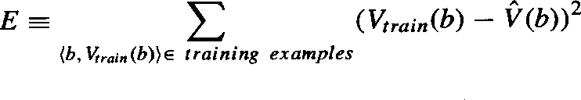
Several algorithms are known for finding weights of a linear function that minimize E. One such algorithm is called the least mean squares, or LMS training rule. For each observed training example it adjusts the weights a small amount in the direction that reduces the error on this training example

LMS weight update rule :- For each training example (b, V_{train}(b))
Use the current weights to calculate V̂ (b)
For each weight w_{i}, update it as

w_{i} ← wi + ƞ (Vtrain (b) - V̂ (b)) xi

Here ƞ is a small constant (e.g., 0.1) that moderates the size of the weight update.

Working of weight update rule

  - When the error (V_{train}(b)- V̂ (b)) is zero, no weights are changed.
  - When (V_{train}(b) - V̂ (b)) is positive (i.e., when V̂ (b) is too low), then each weight is increased in proportion to the value of its corresponding feature. This will raise the value of V̂ (b), reducing the error.
  - If the value of some feature x_{i} is zero, then its weight is not altered regardless of the error, so that the only weights updated are those whose features actually occur on the training example board.

The Final Design
The final design of checkers learning system can be described by four distinct program modules that represent the central components in many learning systems

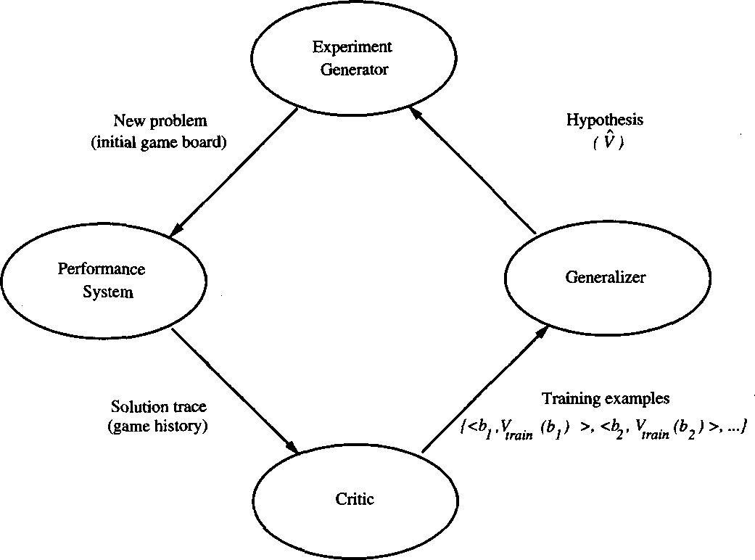

    - The Performance System is the module that must solve the given performance task by using the learned target function(s). It takes an instance of a new problem (new game) as input and produces a trace of its solution (game history) as output.

    - The Critic takes as input the history or trace of the game and produces as output a set of training examples of the target function

    - The Generalizer takes as input the training examples and produces an output hypothesis that is its estimate of the target function. It generalizes from the specific training examples, hypothesizing a general function that covers these examples and other cases beyond the training examples.

    - The Experiment Generator takes as input the current hypothesis and outputs a new problem (i.e., initial board state) for the Performance System to explore. Its role is to pick new practice problems that will maximize the learning rate of the overall system.

The sequence of design choices made for the checkers program is summarized in below figure

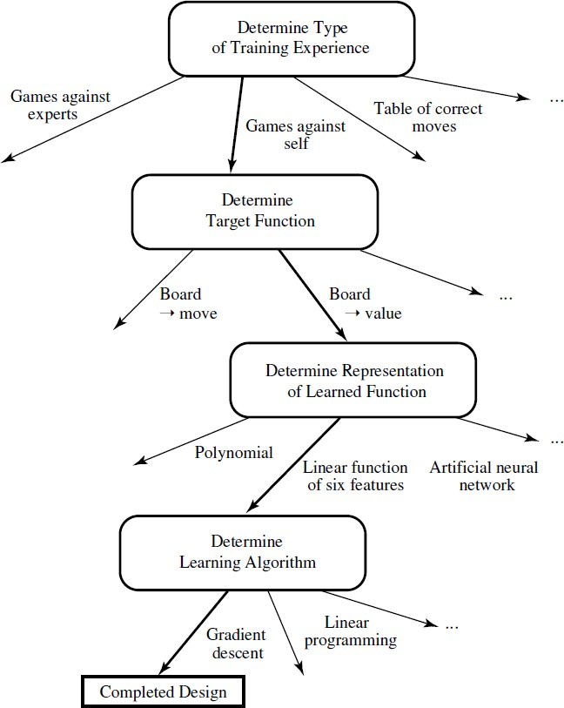

PERSPECTIVES AND ISSUES IN MACHINE LEARNING

Issues in Machine Learning
The field of machine learning, and much of this book, is concerned with answering questions such as the following
- What algorithms exist for learning general target functions from specific training examples? In what settings will particular algorithms converge to the desired function, given sufficient training data? Which algorithms perform best for which types of problems and representations?
- How much training data is sufficient? What general bounds can be found to relate the confidence in learned hypotheses to the amount of training experience and the character of the learner's hypothesis space?
- When and how can prior knowledge held by the learner guide the process of generalizing from examples? Can prior knowledge be helpful even when it is only approximately correct?
- What is the best strategy for choosing a useful next training experience, and how does the choice of this strategy alter the complexity of the learning problem?
- What is the best way to reduce the learning task to one or more function approximation problems? Put another way, what specific functions should the system attempt to learn? Can this process itself be automated?
- How can the learner automatically alter its representation to improve its ability to represent and learn the target function?

Noise in Machine Learning
Real-world data, which is used to feed data mining algorithms, has a number of factors that can influence it. The existence of noise is a major factor in both of these problems. It’s an inevitable problem, but one that a data-driven organization must fix.
Humans are prone to making mistakes when collecting data, and data collection instruments may be unreliable, resulting in dataset errors. The errors are referred to as noise. Data noise in machine learning can cause problems since the algorithm interprets the noise as a pattern and can start generalizing from it.
As a result, by using an algorithm, any data scientist must deal with the noise in data science.
There are many widely used techniques used to extract the noise from any signal or dataset.

Data Preprocessing in Machine learning
Data preprocessing is a process of preparing the raw data and making it suitable for a machine learning model. It is the first and crucial step while creating a machine learning model.
When creating a machine learning project, it is not always a case that we come across the clean and formatted data. And while doing any operation with data, it is mandatory to clean it and put in a formatted way. So for this, we use data preprocessing task.

Why do we need Data Preprocessing?
A real-world data generally contains noises, missing values, and maybe in an unusable format which cannot be directly used for machine learning models. Data preprocessing is required tasks for cleaning the data and making it suitable for a machine learning model which also increases the accuracy and efficiency of a machine learning model.
It involves below steps:
- Getting the dataset
- Importing libraries
- Importing datasets
- Finding Missing Data
- Encoding Categorical Data
- Splitting dataset into training and test set
- Feature scaling

1) Get the Dataset
To create a machine learning model, the first thing we required is a dataset as a machine learning model completely works on data. The collected data for a particular problem in a proper format is known as the dataset.
Dataset may be of different formats for different purposes, such as, if we want to create a machine learning model for business purpose, then dataset will be different with the dataset required for a liver patient. So each dataset is different from another dataset. To use the dataset in our code, we usually put it into a CSV file. However, sometimes, we may also need to use an HTML or xlsx file.

What is a CSV File?
CSV stands for "Comma-Separated Values" files; it is a file format which allows us to save the tabular data, such as spreadsheets. It is useful for huge datasets and can use these datasets in programs.
We can also create our dataset by gathering data using various API with Python and put that data into a .csv file.

2) Importing Libraries
In order to perform data preprocessing using Python, we need to import some predefined Python libraries. These libraries are used to perform some specific jobs. There are three specific libraries that we will use for data preprocessing, which are:
Numpy: Numpy Python library is used for including any type of mathematical operation in the code. It is the fundamental package for scientific calculation in Python. It also supports to add large, multidimensional arrays and matrices. So, in Python, we can import it as:
import numpy as nm
Here we have used nm, which is a short name for Numpy, and it will be used in the whole program.
Matplotlib: The second library is matplotlib, which is a Python 2D plotting library, and with this library, we need to import a sub-library pyplot. This library is used to plot any type of charts in Python for the code. It will be imported as below:
import matplotlib.pyplot as mpt
Here we have used mpt as a short name for this library.
Pandas: The last library is the Pandas library, which is one of the most famous Python libraries and used for importing and managing the datasets. It is an open-source data manipulation and analysis library. It will be imported as below:
Here, we have used pd as a short name for this library. Consider the below image:
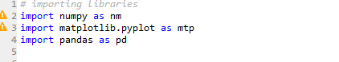

3) Importing the Datasets
Now we need to import the datasets which we have collected for our machine learning project. But before importing a dataset, we need to set the current directory as a working directory. To set a working directory in Spyder IDE, we need to follow the below steps:
- Save your Python file in the directory which contains dataset.
- Go to File explorer option in Spyder IDE, and select the required directory.
- Click on F5 button or run option to execute the file.

Note: We can set any directory as a working directory, but it must contain the required dataset.
Here, in the below image, we can see the Python file along with required dataset. Now, the current folder is set as a working directory.
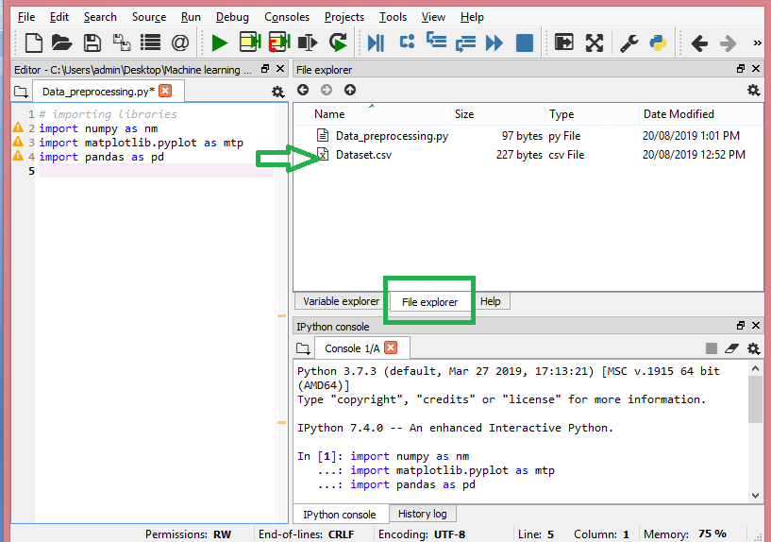
read_csv() function:
Now to import the dataset, we will use read_csv() function of pandas library, which is used to read a csv file and performs various operations on it. Using this function, we can read a csv file locally as well as through an URL.
We can use read_csv function as below:

- data_set= pd.read_csv('Dataset.csv')
Here, data_set is a name of the variable to store our dataset, and inside the function, we have passed the name of our dataset. Once we execute the above line of code, it will successfully import the dataset in our code. We can also check the imported dataset by clicking on the section variable explorer, and then double click on data_set. Consider the below image:
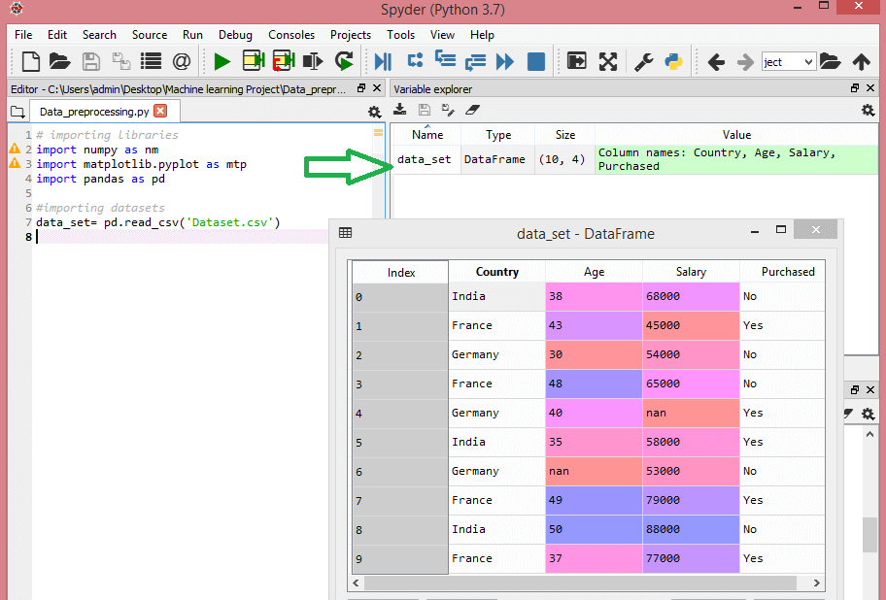
As in the above image, indexing is started from 0, which is the default indexing in Python. We can also change the format of our dataset by clicking on the format option.
Extracting dependent and independent variables:
In machine learning, it is important to distinguish the matrix of features (independent variables) and dependent variables from dataset. In our dataset, there are three independent variables that are Country, Age, and Salary, and one is a dependent variable which is Purchased.
Extracting independent variable:
To extract an independent variable, we will use iloc[ ] method of Pandas library. It is used to extract the required rows and columns from the dataset.
x= data_set.iloc[:,:-1].values
In the above code, the first colon(:) is used to take all the rows, and the second colon(:) is for all the columns. Here we have used :-1, because we don't want to take the last column as it contains the dependent variable. So by doing this, we will get the matrix of features.
By executing the above code, we will get output as:
- [['India' 38.0 68000.0]
- ['France' 43.0 45000.0]
- ['Germany' 30.0 54000.0]
- ['France' 48.0 65000.0]
- ['Germany' 40.0 nan]
- ['India' 35.0 58000.0]
- ['Germany' nan 53000.0]
- ['France' 49.0 79000.0]
- ['India' 50.0 88000.0]
- ['France' 37.0 77000.0]]
As we can see in the above output, there are only three variables.
Extracting dependent variable:
To extract dependent variables, again, we will use Pandas .iloc[] method.

- y= data_set.iloc[:,3].values
Here we have taken all the rows with the last column only. It will give the array of dependent variables.
By executing the above code, we will get output as:
Output:
array(['No', 'Yes', 'No', 'No', 'Yes', 'Yes', 'No', 'Yes', 'No', 'Yes'],
dtype=object)

Note: If you are using Python language for machine learning, then extraction is mandatory, but for R language it is not required.

4) Handling Missing data:
The next step of data preprocessing is to handle missing data in the datasets. If our dataset contains some missing data, then it may create a huge problem for our machine learning model. Hence it is necessary to handle missing values present in the dataset.
Ways to handle missing data:
There are mainly two ways to handle missing data, which are:
By deleting the particular row: The first way is used to commonly deal with null values. In this way, we just delete the specific row or column which consists of null values. But this way is not so efficient and removing data may lead to loss of information which will not give the accurate output.
By calculating the mean: In this way, we will calculate the mean of that column or row which contains any missing value and will put it on the place of missing value. This strategy is useful for the features which have numeric data such as age, salary, year, etc. Here, we will use this approach.
To handle missing values, we will use Scikit-learn library in our code, which contains various libraries for building machine learning models. Here we will use Imputer class of sklearn.preprocessing library. Below is the code for it:

- #handling missing data (Replacing missing data with the mean value)
- from sklearn.preprocessing import Imputer
- imputer= Imputer(missing_values ='NaN', strategy='mean', axis = 0)
- #Fitting imputer object to the independent variables x.
- imputerimputer= imputer.fit(x[:, 1:3])
- #Replacing missing data with the calculated mean value
- x[:, 1:3]= imputer.transform(x[:, 1:3])
Output:
array([['India', 38.0, 68000.0],
['France', 43.0, 45000.0],
['Germany', 30.0, 54000.0],
['France', 48.0, 65000.0],
['Germany', 40.0, 65222.22222222222],
['India', 35.0, 58000.0],
['Germany', 41.111111111111114, 53000.0],
['France', 49.0, 79000.0],
['India', 50.0, 88000.0],
['France', 37.0, 77000.0]], dtype=object
As we can see in the above output, the missing values have been replaced with the means of rest column values.

5) Encoding Categorical data:
Categorical data is data which has some categories such as, in our dataset; there are two categorical variable, Country, and Purchased.
Since machine learning model completely works on mathematics and numbers, but if our dataset would have a categorical variable, then it may create trouble while building the model. So it is necessary to encode these categorical variables into numbers.
For Country variable:
Firstly, we will convert the country variables into categorical data. So to do this, we will use LabelEncoder() class from preprocessing library.

- #Catgorical data
- #for Country Variable
- from sklearn.preprocessing import LabelEncoder
- label_encoder_x= LabelEncoder()
- x[:, 0]= label_encoder_x.fit_transform(x[:, 0])
Output:
Out[15]:
array([[2, 38.0, 68000.0],
[0, 43.0, 45000.0],
[1, 30.0, 54000.0],
[0, 48.0, 65000.0],
[1, 40.0, 65222.22222222222],
[2, 35.0, 58000.0],
[1, 41.111111111111114, 53000.0],
[0, 49.0, 79000.0],
[2, 50.0, 88000.0],
[0, 37.0, 77000.0]], dtype=object)
Explanation:
In above code, we have imported LabelEncoder class of sklearn library. This class has successfully encoded the variables into digits.
But in our case, there are three country variables, and as we can see in the above output, these variables are encoded into 0, 1, and 2. By these values, the machine learning model may assume that there is some correlation between these variables which will produce the wrong output. So to remove this issue, we will use dummy encoding.
Dummy Variables:
Dummy variables are those variables which have values 0 or 1. The 1 value gives the presence of that variable in a particular column, and rest variables become 0. With dummy encoding, we will have a number of columns equal to the number of categories.
In our dataset, we have 3 categories so it will produce three columns having 0 and 1 values. For Dummy Encoding, we will use OneHotEncoder class of preprocessing library.

- #for Country Variable
- from sklearn.preprocessing import LabelEncoder, OneHotEncoder
- label_encoder_x= LabelEncoder()
- x[:, 0]= label_encoder_x.fit_transform(x[:, 0])
- #Encoding for dummy variables
- onehot_encoder= OneHotEncoder(categorical_features= [0])
- x= onehot_encoder.fit_transform(x).toarray()
Output:
array([[0.00000000e+00, 0.00000000e+00, 1.00000000e+00, 3.80000000e+01,
6.80000000e+04],
[1.00000000e+00, 0.00000000e+00, 0.00000000e+00, 4.30000000e+01,
4.50000000e+04],
[0.00000000e+00, 1.00000000e+00, 0.00000000e+00, 3.00000000e+01,
5.40000000e+04],
[1.00000000e+00, 0.00000000e+00, 0.00000000e+00, 4.80000000e+01,
6.50000000e+04],
[0.00000000e+00, 1.00000000e+00, 0.00000000e+00, 4.00000000e+01,
6.52222222e+04],
[0.00000000e+00, 0.00000000e+00, 1.00000000e+00, 3.50000000e+01,
5.80000000e+04],
[0.00000000e+00, 1.00000000e+00, 0.00000000e+00, 4.11111111e+01,
5.30000000e+04],
[1.00000000e+00, 0.00000000e+00, 0.00000000e+00, 4.90000000e+01,
7.90000000e+04],
[0.00000000e+00, 0.00000000e+00, 1.00000000e+00, 5.00000000e+01,
8.80000000e+04],
[1.00000000e+00, 0.00000000e+00, 0.00000000e+00, 3.70000000e+01,
7.70000000e+04]])
As we can see in the above output, all the variables are encoded into numbers 0 and 1 and divided into three columns.
It can be seen more clearly in the variables explorer section, by clicking on x option as:
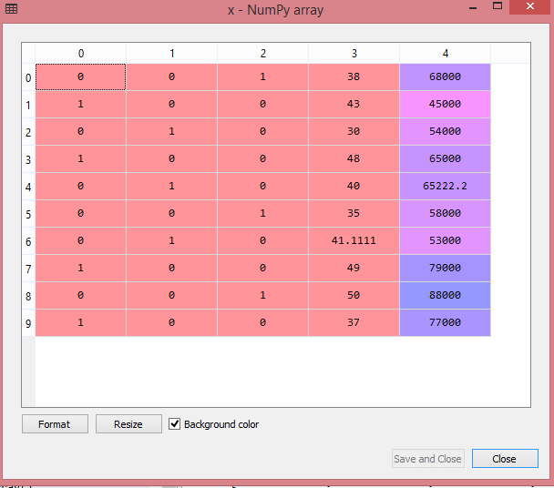
For Purchased Variable:

- labelencoder_y= LabelEncoder()
- y= labelencoder_y.fit_transform(y)
For the second categorical variable, we will only use labelencoder object of LableEncoder class. Here we are not using OneHotEncoder class because the purchased variable has only two categories yes or no, and which are automatically encoded into 0 and 1.
Output:
Out[17]: array([0, 1, 0, 0, 1, 1, 0, 1, 0, 1])
It can also be seen as:
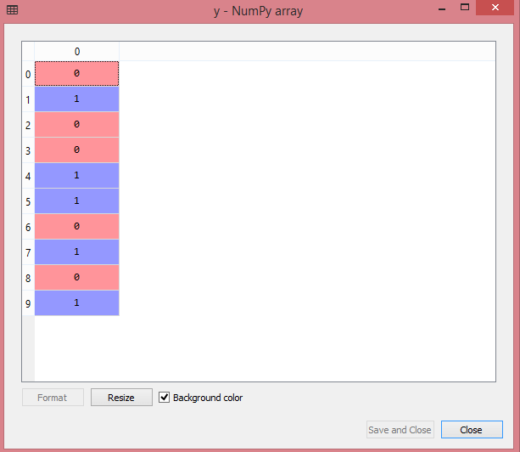

6) Splitting the Dataset into the Training set and Test set
In machine learning data preprocessing, we divide our dataset into a training set and test set. This is one of the crucial steps of data preprocessing as by doing this, we can enhance the performance of our machine learning model.
Suppose, if we have given training to our machine learning model by a dataset and we test it by a completely different dataset. Then, it will create difficulties for our model to understand the correlations between the models.
If we train our model very well and its training accuracy is also very high, but we provide a new dataset to it, then it will decrease the performance. So we always try to make a machine learning model which performs well with the training set and also with the test dataset. Here, we can define these datasets as:
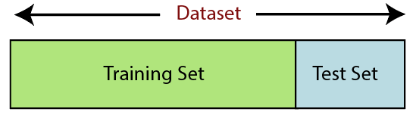
Training Set: A subset of dataset to train the machine learning model, and we already know the output.
Test set: A subset of dataset to test the machine learning model, and by using the test set, model predicts the output.
For splitting the dataset, we will use the below lines of code:

- from sklearn.model_selection import train_test_split
- x_train, x_test, y_train, y_test= train_test_split(x, y, test_size= 0.2, random_state=0)
Explanation:
- In the above code, the first line is used for splitting arrays of the dataset into random train and test subsets.
- In the second line, we have used four variables for our output that are
  - x_train: features for the training data
  - x_test: features for testing data
  - y_train: Dependent variables for training data
  - y_test: Independent variable for testing data
- In train_test_split() function, we have passed four parameters in which first two are for arrays of data, and test_size is for specifying the size of the test set. The test_size maybe .5, .3, or .2, which tells the dividing ratio of training and testing sets.
- The last parameter random_state is used to set a seed for a random generator so that you always get the same result, and the most used value for this is 42.
Output:
By executing the above code, we will get 4 different variables, which can be seen under the variable explorer section.
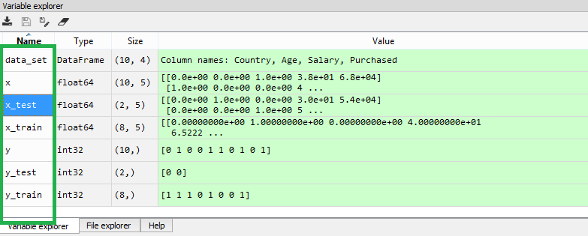
As we can see in the above image, the x and y variables are divided into 4 different variables with corresponding values.

7) Feature Scaling
Feature scaling is the final step of data preprocessing in machine learning. It is a technique to standardize the independent variables of the dataset in a specific range. In feature scaling, we put our variables in the same range and in the same scale so that no any variable dominate the other variable.
Consider the below dataset:
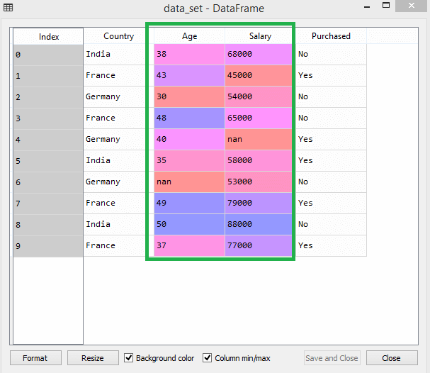
As we can see, the age and salary column values are not on the same scale. A machine learning model is based on Euclidean distance, and if we do not scale the variable, then it will cause some issue in our machine learning model.
Euclidean distance is given as:
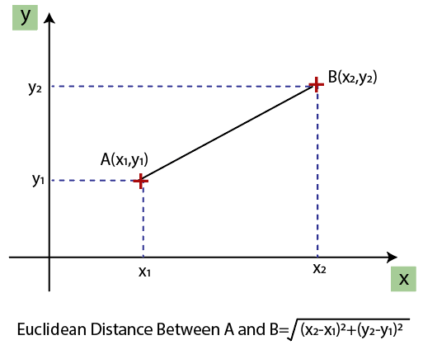
If we compute any two values from age and salary, then salary values will dominate the age values, and it will produce an incorrect result. So to remove this issue, we need to perform feature scaling for machine learning.
There are two ways to perform feature scaling in machine learning:
Standardization
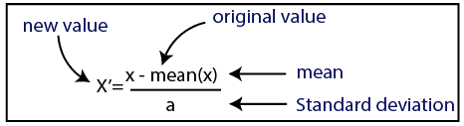
Normalization
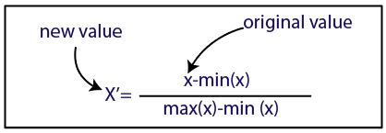
Here, we will use the standardization method for our dataset.
For feature scaling, we will import StandardScaler class of sklearn.preprocessing library as:

- from sklearn.preprocessing import StandardScaler
Now, we will create the object of StandardScaler class for independent variables or features. And then we will fit and transform the training dataset.

- st_x= StandardScaler()
- x_train= st_x.fit_transform(x_train)
For test dataset, we will directly apply transform() function instead of fit_transform() because it is already done in training set.

- x_test= st_x.transform(x_test)
Output:
By executing the above lines of code, we will get the scaled values for x_train and x_test as:
x_train:
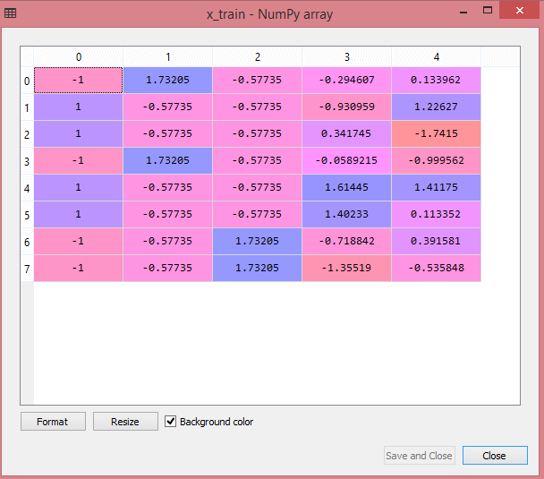
x_test:
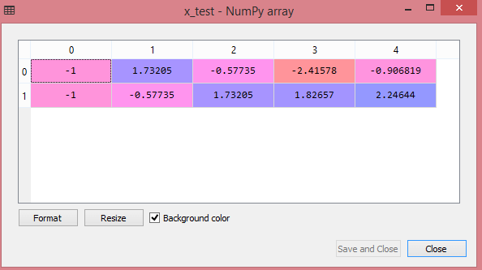
As we can see in the above output, all the variables are scaled between values -1 to 1.

Note: Here, we have not scaled the dependent variable because there are only two values 0 and 1. But if these variables will have more range of values, then we will also need to scale those variables.
Combining all the steps:
Now, in the end, we can combine all the steps together to make our complete code more understandable.
# importing libraries
import numpy as nm
import matplotlib.pyplot as mtp
import pandas as pd

#importing datasets
data_set= pd.read_csv('Dataset.csv')

#Extracting Independent Variable
x= data_set.iloc[:, :-1].values

#Extracting Dependent variable
y= data_set.iloc[:, 3].values

#handling missing data(Replacing missing data with the mean value)
from sklearn.preprocessing import Imputer
imputer= Imputer(missing_values ='NaN', strategy='mean', axis = 0)

#Fitting imputer object to the independent varibles x.
imputerimputer= imputer.fit(x[:, 1:3])

#Replacing missing data with the calculated mean value
x[:, 1:3]= imputer.transform(x[:, 1:3])

#for Country Variable
from sklearn.preprocessing import LabelEncoder, OneHotEncoder
label_encoder_x= LabelEncoder()
x[:, 0]= label_encoder_x.fit_transform(x[:, 0])

#Encoding for dummy variables
onehot_encoder= OneHotEncoder(categorical_features= [0])
x= onehot_encoder.fit_transform(x).toarray()

#encoding for purchased variable
labelencoder_y= LabelEncoder()
y= labelencoder_y.fit_transform(y)
# Splitting the dataset into training and test set.
from sklearn.model_selection import train_test_split
x_train, x_test, y_train, y_test= train_test_split(x, y, test_size= 0.2, random_state=0)

#Feature Scaling of datasets
from sklearn.preprocessing import StandardScaler
st_x= StandardScaler()
x_train= st_x.fit_transform(x_train)
x_test= st_x.transform(x_test)
In the above code, we have included all the data preprocessing steps together. But there are some steps or lines of code which are not necessary for all machine learning models. So we can exclude them from our code to make it reusable for all models.
Training Validation and Test data
- Training data. This type of data builds up the machine learning algorithm. The data scientist feeds the algorithm input data, which corresponds to an expected output. The model evaluates the data repeatedly to learn more about the data’s behavior and then adjusts itself to serve its intended purpose.
- Validation data. During training, validation data infuses new data into the model that it hasn’t evaluated before. Validation data provides the first test against unseen data, allowing data scientists to evaluate how well the model makes predictions based on the new data. Not all data scientists use validation data, but it can provide some helpful information to optimize hyperparameters, which influence how the model assesses data.
- Test data. After the model is built, testing data once again validates that it can make accurate predictions. If training and validation data include labels to monitor performance metrics of the model, the testing data should be unlabeled. Test data provides a final, real-world check of an unseen dataset to confirm that the ML algorithm was trained effectively.
While each of these three datasets has its place in creating and training ML models, it’s easy to see some overlap between them. The difference between training data vs. test data is clear: one trains a model, the other confirms it works correctly,

Bias and Variance
The prediction error for any machine learning algorithm can be broken down into two parts:
- Bias Error
- Variance Error

Bias Error
Bias are the simplifying assumptions made by a model to make the target function easier to learn.
Generally, linear algorithms have a high bias making them fast to learn and easier to understand but generally less flexible. In turn, they have lower predictive performance on complex problems that fail to meet the simplifying assumptions of the algorithms bias.
- Low Bias: Suggests less assumptions about the form of the target function.
- High-Bias: Suggests more assumptions about the form of the target function.
Examples of low-bias machine learning algorithms include: Decision Trees, k-Nearest Neighbors and Support Vector Machines.
Examples of high-bias machine learning algorithms include: Linear Regression, Linear Discriminant Analysis and Logistic Regression.

Variance Error
Variance is the amount that the estimate of the target function will change if different training data was used.
The target function is estimated from the training data by a machine learning algorithm, so we should expect the algorithm to have some variance. Ideally, it should not change too much from one training dataset to the next, meaning that the algorithm is good at picking out the hidden underlying mapping between the inputs and the output variables.
Machine learning algorithms that have a high variance are strongly influenced by the specifics of the training data. This means that the specifics of the training have influences the number and types of parameters used to characterize the mapping function.
- Low Variance: Suggests small changes to the estimate of the target function with changes to the training dataset.
- High Variance: Suggests large changes to the estimate of the target function with changes to the training dataset.
Generally, nonlinear machine learning algorithms that have a lot of flexibility have a high variance. For example, decision trees have a high variance, that is even higher if the trees are not pruned before use.
Examples of low-variance machine learning algorithms include: Linear Regression, Linear Discriminant Analysis and Logistic Regression.
Examples of high-variance machine learning algorithms include: Decision Trees, k-Nearest Neighbors and Support Vector Machines.

Bias-Variance Trade-Off
The goal of any supervised machine learning algorithm is to achieve low bias and low variance. In turn the algorithm should achieve good prediction performance.
You can see a general trend in the examples above:
- Linear machine learning algorithms often have a high bias but a low variance.
- Nonlinear machine learning algorithms often have a low bias but a high variance.
The parameterization of machine learning algorithms is often a battle to balance out bias and variance.
Below are two examples of configuring the bias-variance trade-off for specific algorithms:
- The k-nearest neighbors algorithm has low bias and high variance, but the trade-off can be changed by increasing the value of k which increases the number of neighbors that contribute t the prediction and in turn increases the bias of the model.
- The support vector machine algorithm has low bias and high variance, but the trade-off can be changed by increasing the C parameter that influences the number of violations of the margin allowed in the training data which increases the bias but decreases the variance.
There is no escaping the relationship between bias and variance in machine learning.
- Increasing the bias will decrease the variance.
- Increasing the variance will decrease the bias.
There is a trade-off at play between these two concerns and the algorithms you choose and the way you choose to configure them are finding different balances in this trade-off for your problem
In reality, we cannot calculate the real bias and variance error terms because we do not know the actual underlying target function. Nevertheless, as a framework, bias and variance provide the tools to understand the behavior of machine learning algorithms in the pursuit of predictive performance.

Summary
- Bias is the simplifying assumptions made by the model to make the target function easier to approximate.
- Variance is the amount that the estimate of the target function will change given different training data.

